Planning and Progress Report - Student 5

* **Group Number**: C1.034
* **Repository**: https://github.com/CarlosCerdaMorales/dp2-c1-034
* **Workgroup Members** **and Corporate Emails:**

Loubna Founoun Elaoud: [loufouela@alum.us.es](mailto:loufouela@alum.us.es)

Carlos Cerda Morales: [carcermor@alum.us.es](mailto:carcermor@alum.us.es)

José Luis Moraza Vergara: [josmorver@alum.us.es](mailto:josmorver@alum.us.es)

Claudia Oviedo Govantes: [claovigov@alum.us.es](mailto:claovigov@alum.us.es)

Sergio Cantillo Blanco: [sercanbla@alum.us.es](mailto:sercanbla@alum.us.es)

* **Date**: Thursday 20, February 2024

**Table Of Contents**

1. Executive Summary 3

2. Revision Table 3

3. Introduction 3

4. Contents 3

4.1 Planning 3

4.2 Progress 5

5. Conclusions 6

6. Bibliography 6

# Executive Summary

This document presents the task planning for the first deliverable and compares the initial estimated cost with the actual cost. Regarding progress, All assigned tasks were successfully completed; however, some took longer than expected due to unforeseen challenges.

# Revision Table

|  |  |  |
| --- | --- | --- |
| **Revision Number** | **Date** | **Description** |
| 1.0 | Thursday 20, February 2025 | Initial draft |

# Introduction

This document aims to evaluate the performance of Student #5 in the first deliverable. It details and explains task assignments, their progress, and the estimated versus actual values for each. To enhance organization, this information has been structured in a table, including both the estimated and actual time spent on each task.

The document is divided into two sections: “Planning" and "Progress".

My roles in this deliverable were Analyst, Developer, and Tester.

# Contents

## 4.1 Planning

The plan was to first complete all the mandatory tasks and, if time allowed before the deliverable deadline, work on the supplementary ones.

|  |  |  |  |  |
| --- | --- | --- | --- | --- |
| **Issue’s ID** | **Title** | **Description** | **Planned time** | **Actual time** |
| #80 | Modify anonymous menu | Modify the anonymous menu so that it shows an option that takes the browser to the home page of your favourite web site. | 20 minutes | 2 hours |
| #75 | Individual Dashboard Link in GitHub | Provide a link to your planning dashboard in GitHub to review the tasks | 10 minutes | 20 minutes |
| #76 | Individual Analysis Report | Produce an analysis report. | 1 hour | 2 hours |
| #77 | Planning and Progress report | Produce a planning and progress report. | 2 hours | 1 hour |
| Intentionally blank | Lectures | Attend theory lessons | 20 hours | 20 hours |
| Intentionally blank | Study | Study theory lessons and understand the framework | 2 hours | 5 hours |
| Intentionally blank | Follow-ups | Attend follow-ups and incorporate lecturer’s recommendarions | 2 hours | 2 hours |

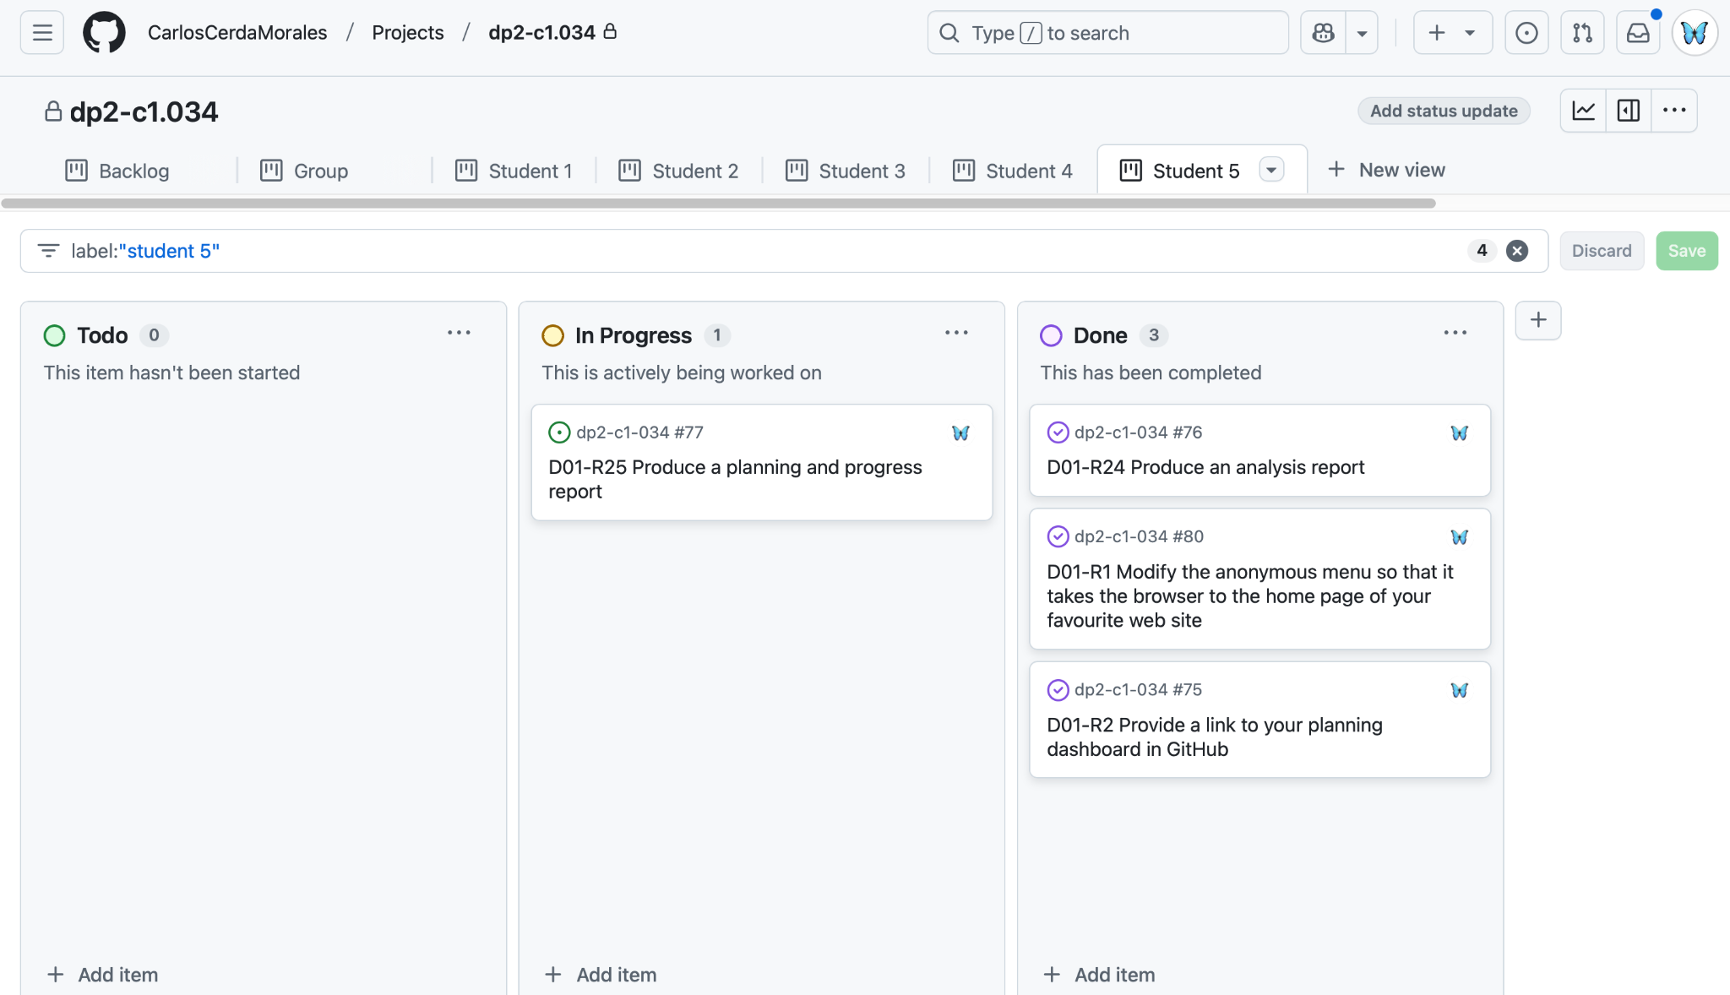

Dashboard near the end of the deliverable: The decision to create individual planning views was made late in the process, so I do not have earlier images.

**Planned costs**

|  |  |  |  |  |
| --- | --- | --- | --- | --- |
| **Title** | **Role** | **Cost per hour** | **Planned Time** | **Cost** |
| Modify anonymous menu | Developer | 20.00€/h | 20 minutes | 6.66€ |
| Individual Dashboard Link in GitHub | Every role | 20.00€/h | 10 minutes | 3.33€ |
| Individual Analysis Report | Analist | 30.00€/h | 1 hour | 30.0€ |
| Planning and Progress report | Analist | 30.00€/h | 2 hours | 60.0€ |
| Lectures | Every role | 20.00€/h | 20 hours | 400.0€ |
| Study | Every role | 20.00€/h | 2 hours | 40.0€ |
| Follow-ups | Every role | 20.00€/h | 2 hours | 40.0€ |

Total estimated cost = 579.93€

## 4.2 Progress

The goal was to complete all mandatory tasks first and, if time permitted, work on the supplementary ones. Since all tasks were successfully completed, the performance is considered excellent.

**Real costs**

|  |  |  |  |  |
| --- | --- | --- | --- | --- |
| **Title** | **Role** | **Cost per hour** | **Actual time** | **Cost** |
| Modify anonymous menu | Developer | 20.00€/h | 2 hours | 40.0€ |
| Individual Dashboard Link in GitHub | Every role | 20.00€/h | 20 minutes | 6.66€ |
| Individual Analysis Report | Analist | 30.00€/h | 2 hours | 60.0€ |
| Planning and Progress report | Analist | 30.00€/h | 1 hour | 30.0€ |
| Lectures | Every role | 20.00€/h | 20 hours | 400.0€ |
| Study | Every role | 20.00€/h | 5 hours | 100.0€ |
| Follow-ups | Every role | 20.00€/h | 2 hours | 40.0€ |

Total actual cost = 676.66€

Although there was a difference of €100, it is considered acceptable.

No significant **conflicts** arose during the deliverable. However, some rework was necessary when the planning dashboard had to be created twice to align with the subject’s requirements and methodology.

My **performance** indicator is the completion of all mandatory tasks. Since I successfully completed all required tasks within the given timeframe, my performance for this deliverable is considered excellent.

# Conclusions

Some tasks took longer than initially estimated due to unexpected issues. However, these challenges were successfully addressed before the planned submission deadline.

# Bibliography

If there’s no relevant bibliography, write “intentionally blank”.